**Tutorial 11**

**Graphs and Sorting techniques**

**Instructions**

1. All tutorial sheets will be posted on the Google Classroom.

2. Students are advised to submit tutorial sheets solutions in classroom.

Q1. Perform DFS and BFS traversal on the following graph. Show the contents of stack/queue at every step.

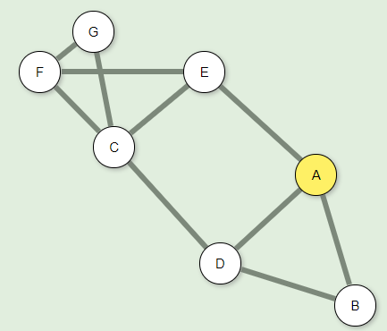

Q2. Write a program to construct the above graph (in Q1) using adjacency list

Q3. Given the following list of numbers: [21, 1, 26, 45, 29, 28, 2, 9, 16, 49, 39, 27, 43, 34, 46,40]

What will be the array after 3 recursive calls to merge sort? Explain with the help of an algorithm the recursive calls for the merge sort.

Q4. Apply the quick sort for the given elements: 50,23,9,18,61,32